1. Topics & Homework  
     
   Please make sure the field are all aligned. The textboxes are not left aligned See image1 (red circle) Please make the + sign blue icon into a textual item like: Add a file, and make the color consistent like a brown colour. **Image1**



**Image1**  
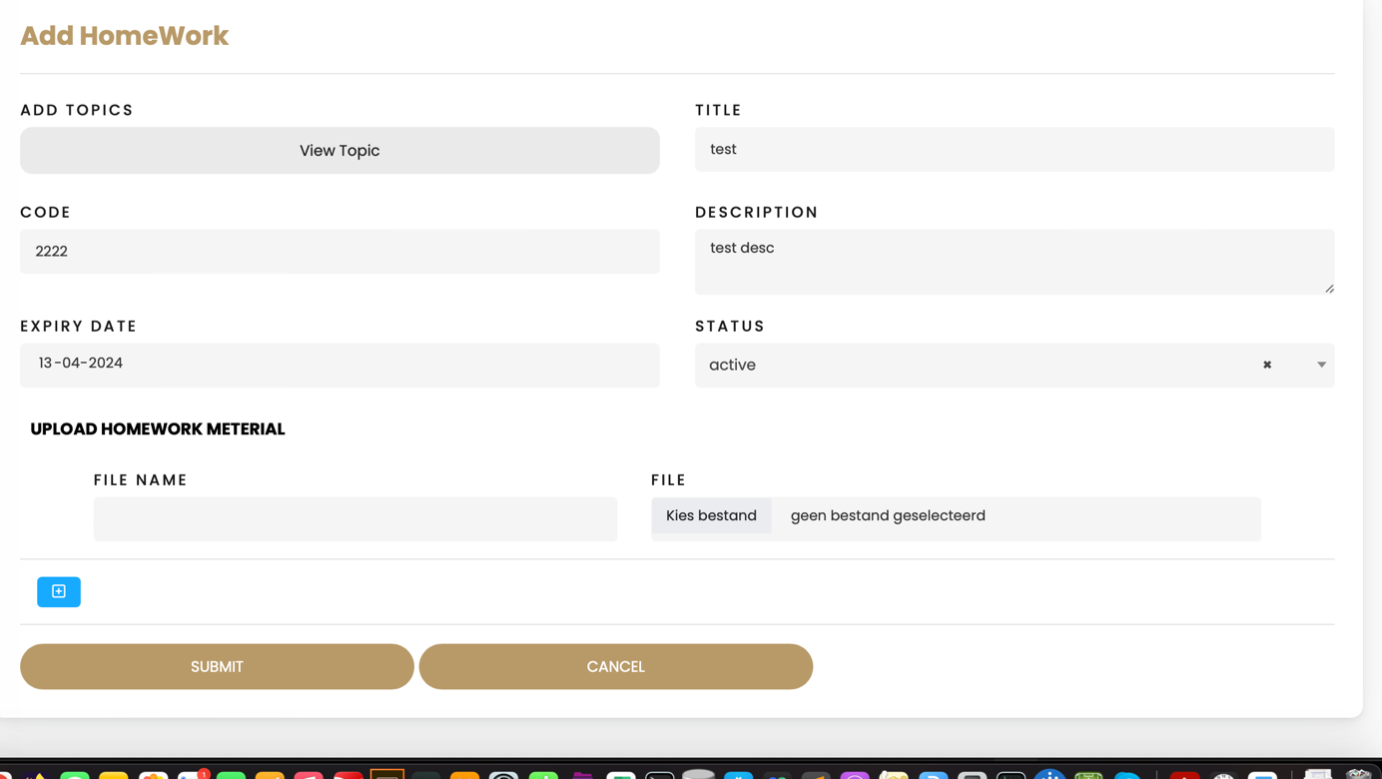

1. If we add homework to the list of homework. How do we give this homework to the student through chat/email ? Image2



Image2  
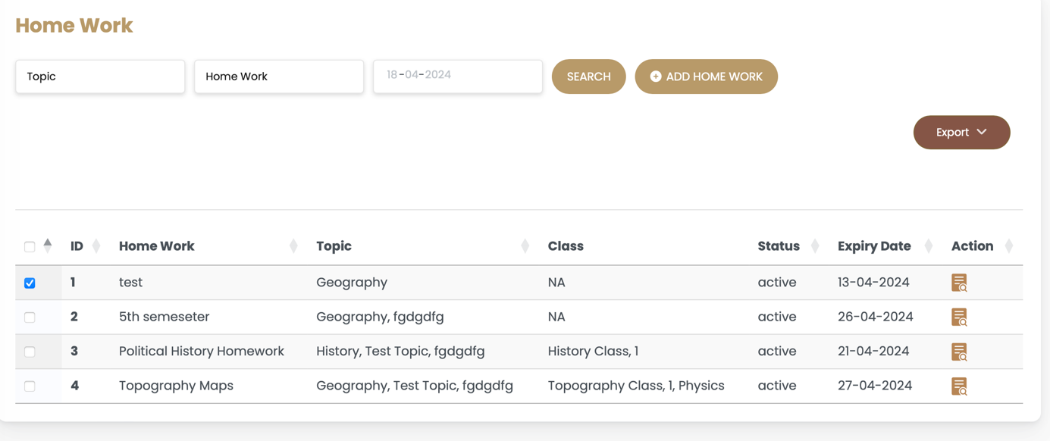

1. Please make an item in Trello regarding the redesign of exports , it is now not aligned and too chaotic . Imag3

Image3  
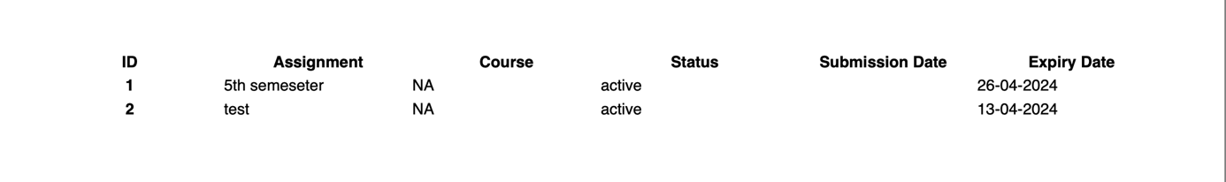

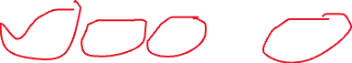

1. The language setting does not work: See image4 The navigation pane is still English and some of the menu tables are still in english

Image4  
  
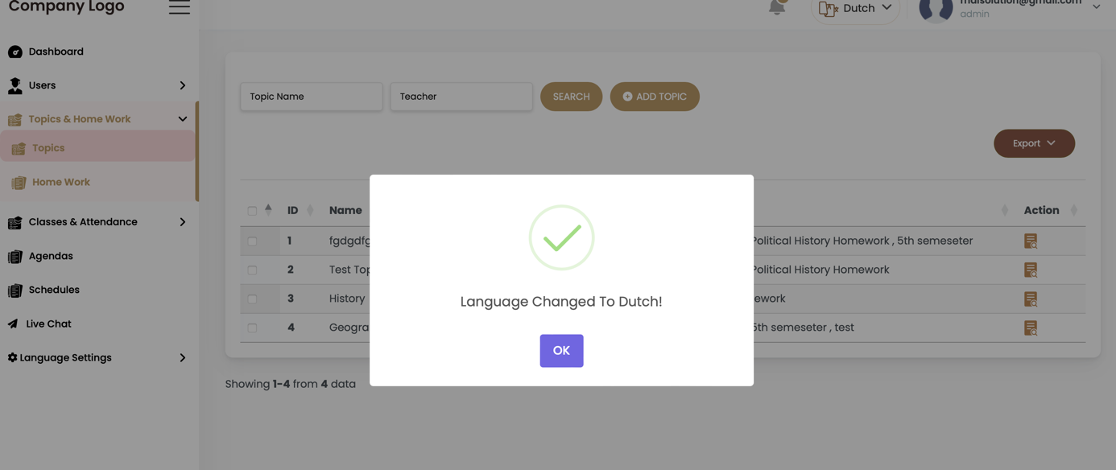

1. Users:  
     
   Student: There are two text boxes names Staat and Stad, Stad – City and is sufficient.  
   see image5, there are some field boxes that needs to be shown after creation like which class he/she is part of , who is the parent etc…  
     
   Image 5  
   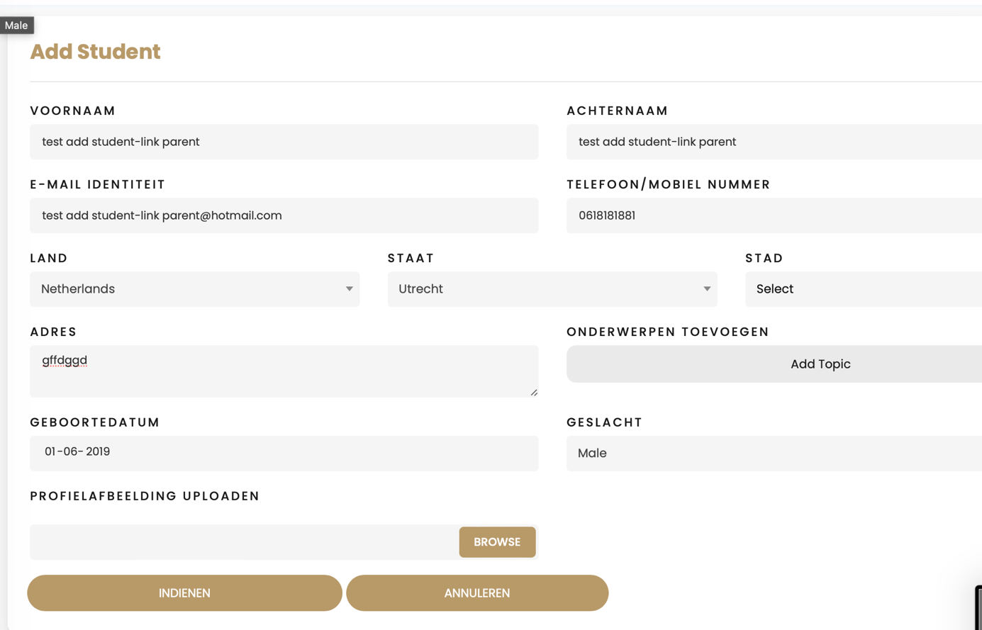



1. Parent:  
   How can we add student to the parent ? it only show no data found ? image6

image6  
  
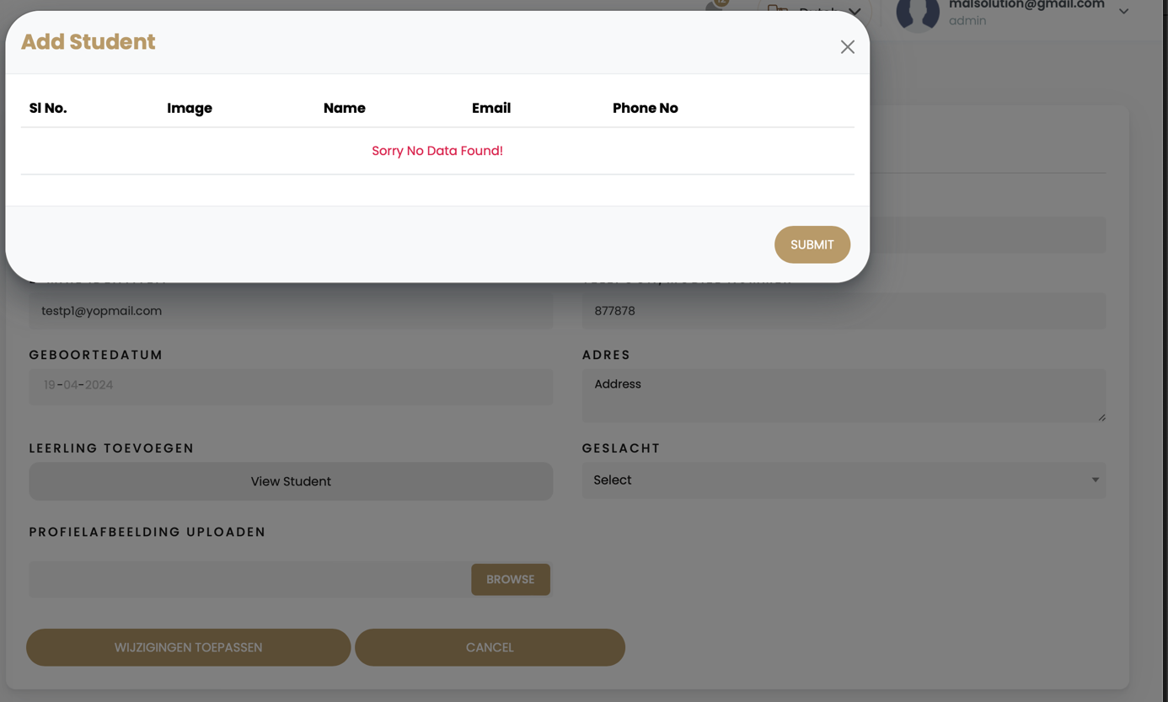

1. The Livechat gives an error:image7  
     
   image7  
     
   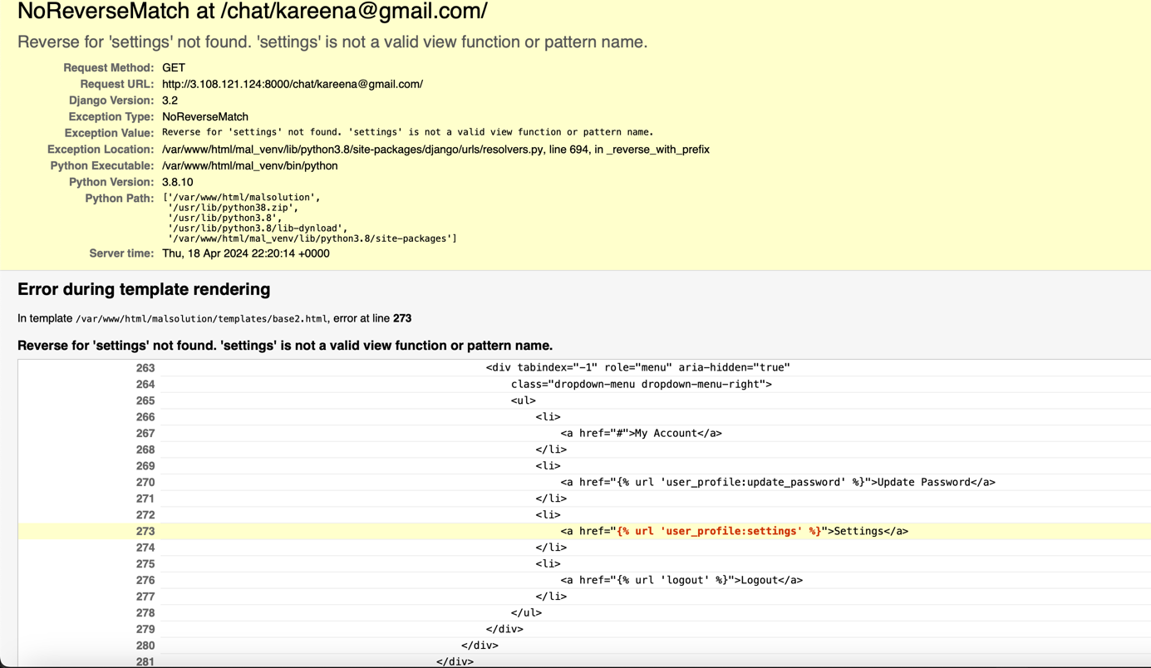
2. Language text details also give error: image8

Image8  
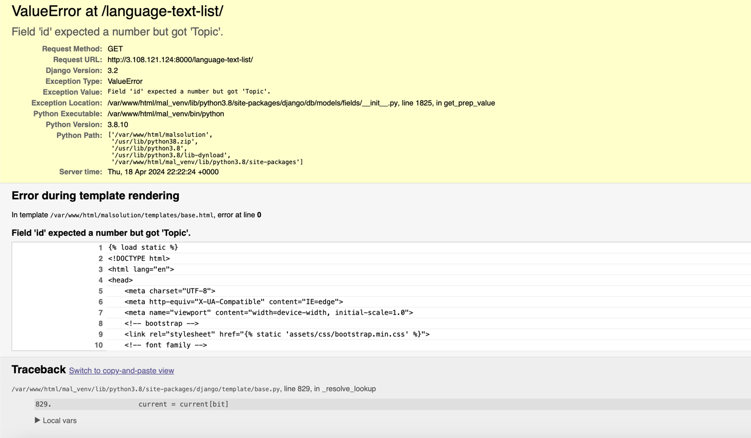

1. Attendance:  
     
   How can I select a class with student on a specific date and mark if there are absent or not ? I only see now a student list if I click on it. Image9 en 10

Image9  
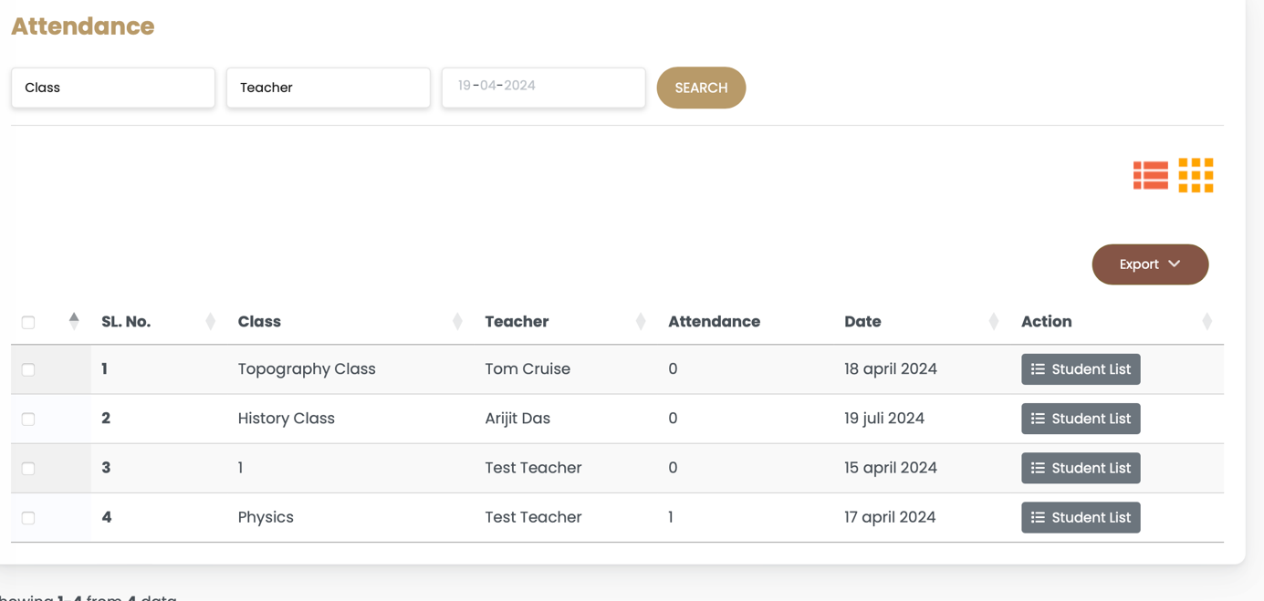

Image10

